**MOOC Recommendation System**

**Abstract**

Choosing a course from a large list of courses could prove to be a challenging job for students. In order to solve this problem the proposed approach uses a recommendation system which would suggest courses to the students. The idea is novel because the basis is recommendations, based on the similarities of the student who is asking for the recommendations with the students who have taken up and rated the course earlier, rather than basing the recommendations purely on a knowledge base. In the case of new students the approach uses a set of parameters and a knowledge base is developed for such students. The initial approach is collaborative based where, user item matrix is considered for getting the score of the user and their rating for the similarity & clustering. The proposed recommender system performs better by mitigating the weakness of basic individual recommender systems along with improving the classifiers used in real-time. This is primarily done by analysing each user currently using the system.

**Keywords: Course recommendation system, Collaborative, User-Item Matrix.**

1. **Introduction**

The course recommender system would suggest best suitable courses to the new students after taking some inputs from him/her on some important attributes that will be needed to find the similar users to this new student. This recommendation should be based on the attributes given by the student and should give the best suitable course. The system should also be able to do semantic analysis of the user’s reviews and should bi-furcate them into good or bad reviews [4]. The system should also be well acquainted with the new courses added to various sites, whose users are not available and should identify the reviewed course to be good or bad according to the review. The proposed system should have a User Interface for the new user, where he or she can enter his or her details and search for the course needed and should also contain a User Interface which would show the courses recommended.

Clearly explain and write the limitations with the existing course recommendations system……………….

The purpose of the proposed approach is to recommend the user the best course from a large number of courses available on different sites on the same field of interest. It helps the user to save his or her precious time and relieves from overhead to search over the internet about the course. One of the limitations with searching and reading thousands of comments and reviews is that they may be discrete and analogous. The user (due to human limitations) is not able to search all the sites and all the courses available on a particular topic. This gives the potential motivation to design a system which maintains a dataset of users and their reviews on different courses on different sites.

The proposed system analyzes the best course taken by a similar group of users on the basis of their reviews on the courses [1].

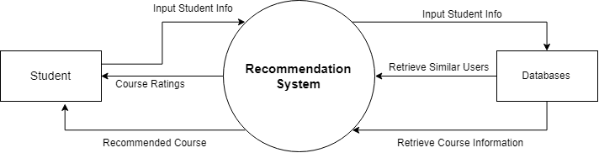

**Figure 1: The Level 0 Data Flow Diagram of the Proposed Approach**

The user is then prompted to fill in a questionnaire. In cases of cold start, the user answers are taken as input to find the similar existing users. The proposed system then suggests the course best reviewed by the similar group of users.

In order to understand the structure of the proposed recommendation a dataflow diagram is presented in Figure 1. It depicts the contextual level DFD which shows complete recommendation system design and emphasizes the way it interacts with external entities. It only contains one process that generalizes the function of the entire system in relationship to external entities. The implementation of the proposed approach is covered in the subsequent sections with detailed analysis.

The rest of the paper is organized as follows: section II presents the motivation of the proposed approach. Section III and IV details related work and the proposed framework of the recommendation system. Section V………………….

1. **Motivation**

The proposed approach aims at suggesting an optimum course for each student separately. This would give each user (student) the flexibility to try new courses, which he/she would be able to complete within the stipulated time and would help the user to gain knowledge using these courses. The user will be able to access the course with confidence without conceiving whether the suggested course would be too easy or too difficult for him/her to understand. This system would also save the time of user which could otherwise have been lost due to sheer number of online courses available on the internet.

1. **Related Work**
2. **Proposed Framework**

Course recommendation is a special project taking into consideration the problems a student goes through in his/her daily life, by fixing it and can be used by any student with a keen interest to learn and grow.

The course recommender is one of the most powerful tools a student can get his hands on, it is one of the tools that is a game changer in terms of being effective and providing results to the student. This helps the student/user to utilize his time effectively.

As students know how big the web really is and in this ocean of information finding the one course that they need is too tough and going through numerous pages to find the best course is not that effective approach so the proposed approach tackles this daily problem and creates the course recommendation system[1]. To learn new things there are multiple websites like Udemy, Coursera etc. Where one can search the course they want that’s fine but how to know which one is the best they don’t know every website that is there they have not gone through all the courses present at that website. Ratings can be deceiving and so many courses have so many ratings [5] which among them is for you so the proposed project has been created. This project provides the one with the best course for them in the whole of the internet which will give you the best result there is.

The proposed algorithm also considers how well versed the user is with the subject and also keeps in consideration their older courses taken to recommend the best course there because being a smart worker is always better than being a hard worker. The recommended courses can be paid or free.

But for the purpose of this project all courses considered are free courses as most students try to get the audited version for free to get the course material .The used algorithms can be discussed with fair brevity and can be understood from the documentation of the course files included in the project. Most algorithms are standard algorithms and can be implemented with fair ease by including libraries and adjusting their parameters.

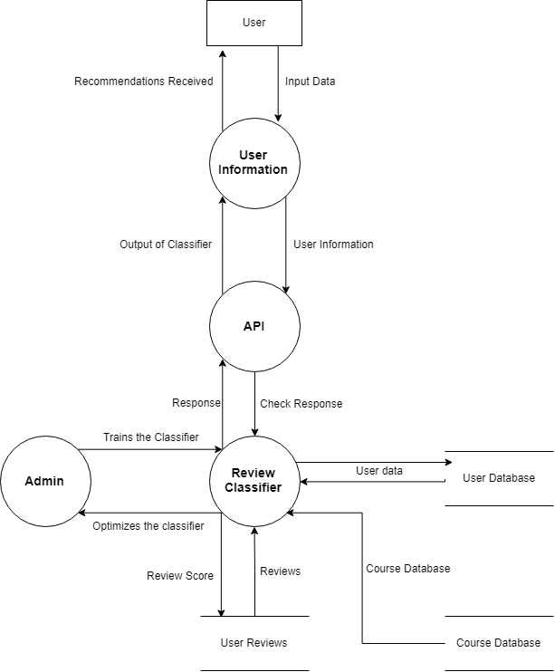

**Figure 2: DFD Level 1**

With reference to Figure 1, in Figure 2, shows the break-up of the single process into many sub processes which are part of the recommender system and how they transform and move through these sub processes.

Expalin Figure 2 here

In Figure 3, the design of the sentiment training classifier is elaborated with the help of a flowchart. Describe the flowchart in your words…



**Figure 3: Training dataset flow chart for sentiment from course reviews**

The flow of process for training the classifier to rate the courses is based on the user’s intent and reviews. Firstly, the dataset for course review with name of each course and their review is included into the program [8]. Once the set of review has been added the next step is to pre-process the dataset and to remove any anomaly present in the data that could cause the system to give inaccurate ratings to the courses. Such as the language of text, null values etc. The next step is to make feature set from given dataset to get the best features so that each review can be correlated to certain words that are important words and that define the intent of the user. Once the feature set of the data has been made next step is to select the classifier to get the optimum result so here in the intended project Naive Bayes binary classifier has been used for initial purpose so as to rate the data as 1 for bad and 5 for good. NLP library has the Naive Bayes function both multinomial and binary function [6] included so the project used the inbuilt Naïve Bayes function of ‘nltk’ as the classifier. Once the classifier has been chosen the next step is to divide the data into testing data and training data which can be done with the help of cross validations train test split [5]. For the project the test set taken is divided based on the 4:1 ratio Once the training of the data has been done the classifier was adjusted to achieve and optimum accuracy with Naive Bayes and approximately 70% was the result the algorithm of Naive Bayes was able to achieve in the specific case of this project. The intention of the above process is to include as many reviews so that if a user gives a new review it can be labelled and the classifier could be adjusted further to give adjusted score to each course for getting the best courses and the worst courses based on the selected features of the course review given by the current user [3].

1. **Working Methodology**

Firstly as the label for each course is available any user needs to login to the system to access his/her data. Once a user registers by answering certain important questions which help the system form a knowledge base for initial recommendation to the new user he/ she can access the recommended courses [1]. Now coming to the backend part it functions based on the collaborative model of recommendation system .Where similar users receive similar recommendations. To achieve the proposed model a user item matrix is made using the data from the previously acquired user data where each user has given review for courses they have done or taken up earlier.



**Figure 4: Course of action for making a collaborative recommender system**

Certain key factors which influence the recommendation such as the length of course needed and the year of study of the student have been taken as the crucial point for making the recommendation [2]. Now the next step is to give a structure or score to each of such user who has given review which has been done by employing the method of average score[2] by giving each feature a score and taking average of all such features.

Once the score is calculated a group or cluster of user has been made by help of K-means clustering [2] where ‘k’ has been taken as the number of courses considered for the purpose of training the score classifier of linear regression. A new user can be made to login and his/her score can be calculated based on the points or features question and recommendations can be considered based on the closeness to the mean points. K means is as iterative algorithm which intends to group datasets based on their closeness to one other or similarity to one another. The recommendation user similarity so they are in true nature with the collaborative model and have been optimized by suggesting the top 5 courses or recommendations to ease the search.

1. **Functional Requirements and Settings in Training and Testing Phase**

In this section, the functional requirements and settings in training and testing phase have been elaborated. The official definition of a functional requirement is that it essentially specifies something the system should do. Typically, functional requirements will specify a behavior or function of the system under the consideration.

* It should ask relevant questions from the user.
* It should be able to take input as the answers provided by the user.
* It should display the list of recommended courses.

Hardware requirements are the requirements needed by the external system using its hardware components so that it is able to run the desired applications within proper response time and with better performance. The implementation is conducted on a Pentium IV processor with 2GB RAM and 8 GB storage. The software requirements are the different software’s needed by the system to run the application properly. The application is made using Python IDE (PyCharm) NLTK toolkit with Numpy.

The data set was extracted through a web scrapper based on node which is a JavaScript based runtime environment build on chromes v8 JavaScript engine using packages like express which is fast, un-opinionated, minimalist web framework for Node.js.

The objective was to make sure that test set met the following criteria it was supposed to be large enough to yield statistically meaningful results and is representative of the data set as a whole getting a dataset with similar characteristics to that of the training set. As our set meets the preceding conditions our goal was to create a model that generalizes well to the new data. The results were not getting high accuracy that might have indicated that the test data leaked into the training set. It was inadvertently trained on some test data as a result we measured accurately about how well our model generalizes to new data.

Here in the considered project model cross validation train/test split uses a 1:4 ratio for test:train data where 20 % data is used for testing and to avoid overfitting the training data is taken to be as random as possible by shuffling the dataset.

1. **Experimental Result and Analysis**

In this section, the detailed experimental results with analysis are presented. The experimental results are validated using python notebook functions (as given in the screenshots). The design of this section is further divided into five subsections (each of which are explained in detail with the results). For the readers, Figure 5 clearly depicts these five subsections.

**Experimental Result and Analysis**

**E. Scoring Mechanism**

**A. Pre-processing of Data**

**B. Constructing Feature Set**

**D. User-Item Matrix**

**C. Training Process**

**Figure 5: Detailed Design of Section V: Experimental result and Analysis**

The five subsections depicted in Figure 5, are the five steps for constructing recommendation system. The proposed system uses *jupyter notebook* for implementation of each module and the pre-requisites mentioned above require *nltk.download()* function to download the various libraries. The loading of dataset into python is helped by the use of *pandas* [5]. *Numpy library* is used for ease of processing. The loaded datasets has been shown in Figure 6. Where the reviews have a serial no and the text, and the course id . ‘*nltk’* library has been used to deal with the pre-processing.

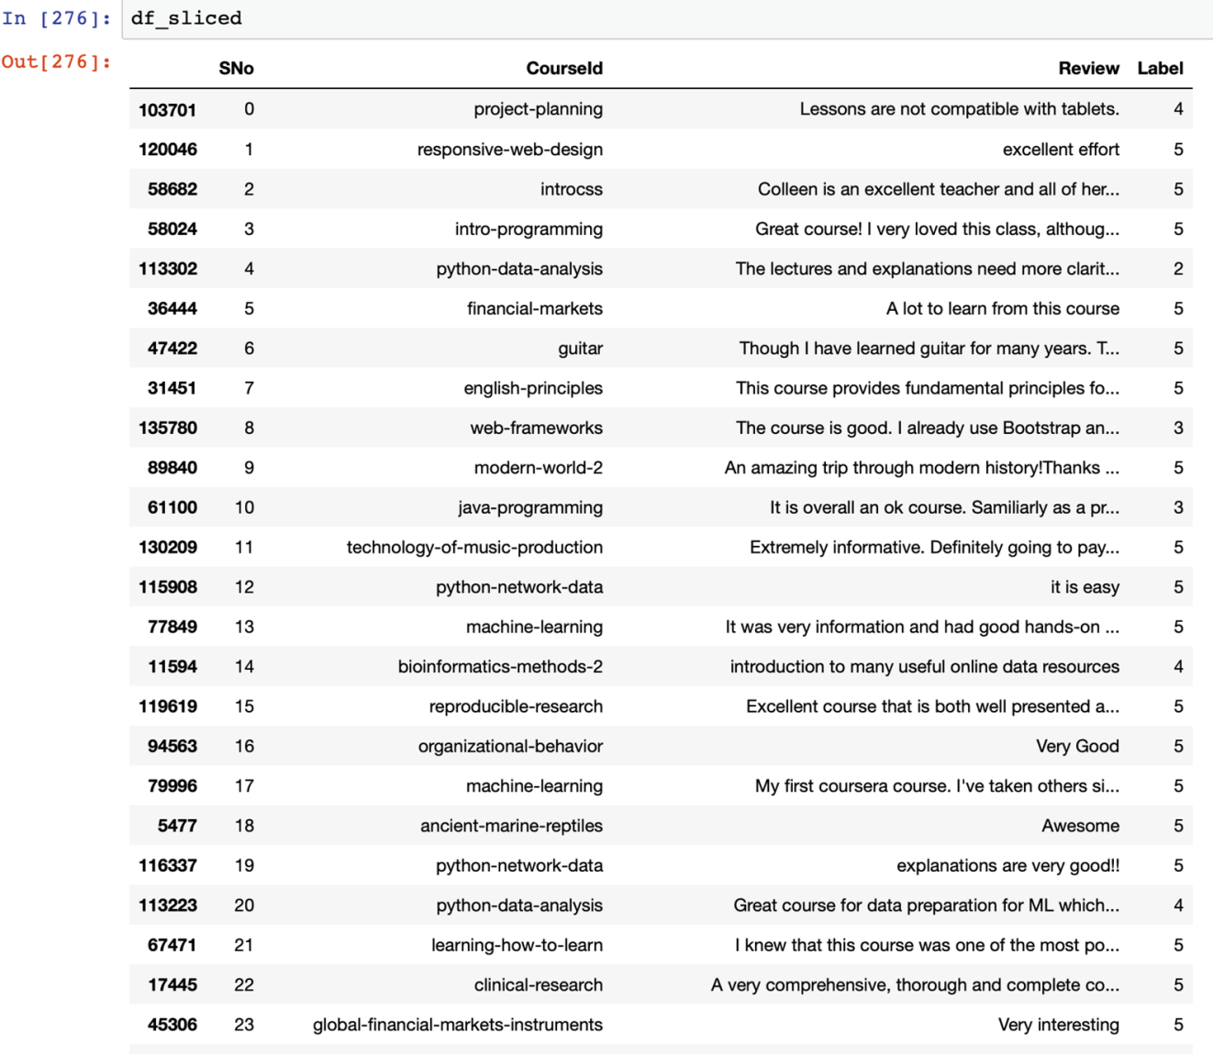

**Figure 6: Set of reviews loaded into ipython notebook**

1. **Preprocessing of data**

Once the data has been loaded the next step involves the process of preprocessing the data. This step includes selecting only the English reviews which has been done with the help of enchant library where the first word of a set of 10000 reviews has been selected and checked using the enchant if it was not in English then its index was stored in a array and the set was subtracted from 10000 to get new indexes which contained only English reviews [5]. This preprocessing of data can be seen in the Figure 7.

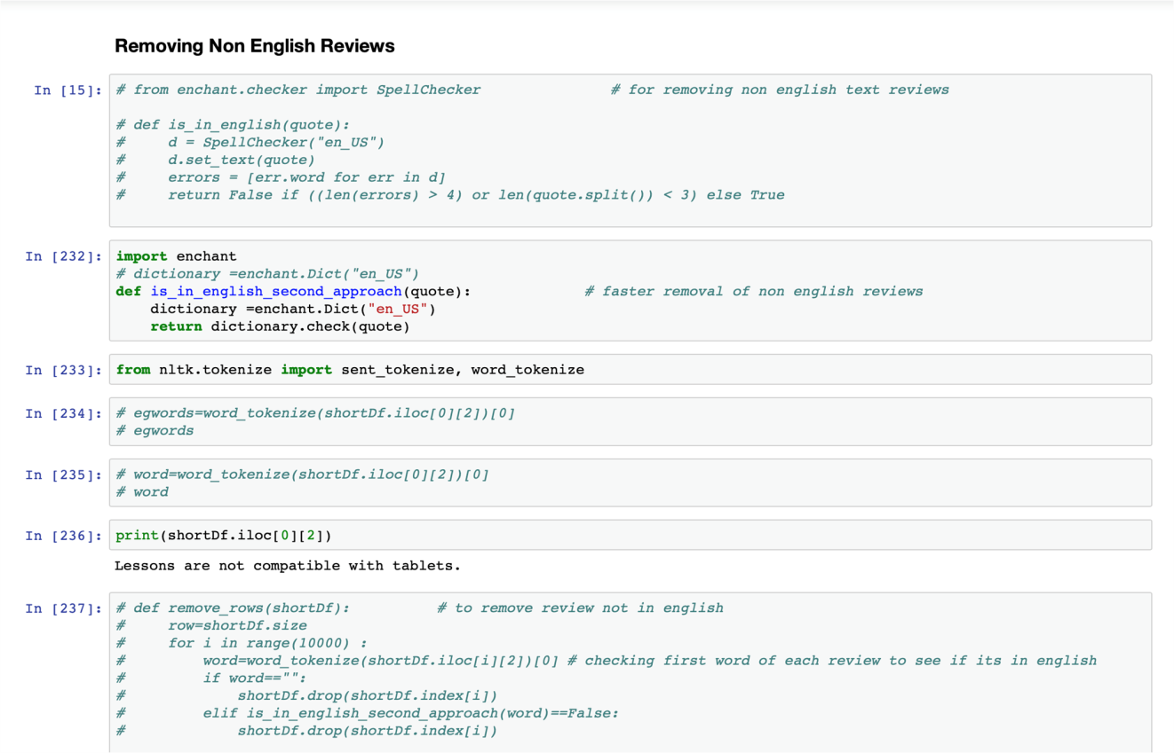

**Figure 7: Function is_in_english_second_approach() which makes only English reviews available**

The motive behind the use of *enchant function* rather than using the *‘nltk’* inbuilt library function is to make a separate list of English words only and to create a new table of such reviews instead of removing them from current table. This helps in effective computation of the text. Code snippet for the same is shown in the Figure 8.



**Figure 8: Enchant function**



**Figure 9: Words of reference**

Words for reference is the array which has all the first words which are checked using enchant for getting the index of non-English words and to remove them from the total sets. This has been shown in Figure 9 and 10.



**Figure 10: Indexes to drop non English reviews**



**Figure 11: New array of English reviews**

In this phase, the non-English indexed reviews have been removed from all reviews and new array of indices to keep have been constructed [7]. For easy reference, this is shown in figure 11.

1. **Constructing Feature Set**

Once the pre-processing of data is done, the next step involves the selection of features. In order to select the features from reviews the most frequent 3000 words form the set of review words were selected as features. Further, to select most common words *‘nltk’* inbuilt library function most_common() is used and pandas inbuilt function unique() [3] is used. This can be seen in Figure 12.

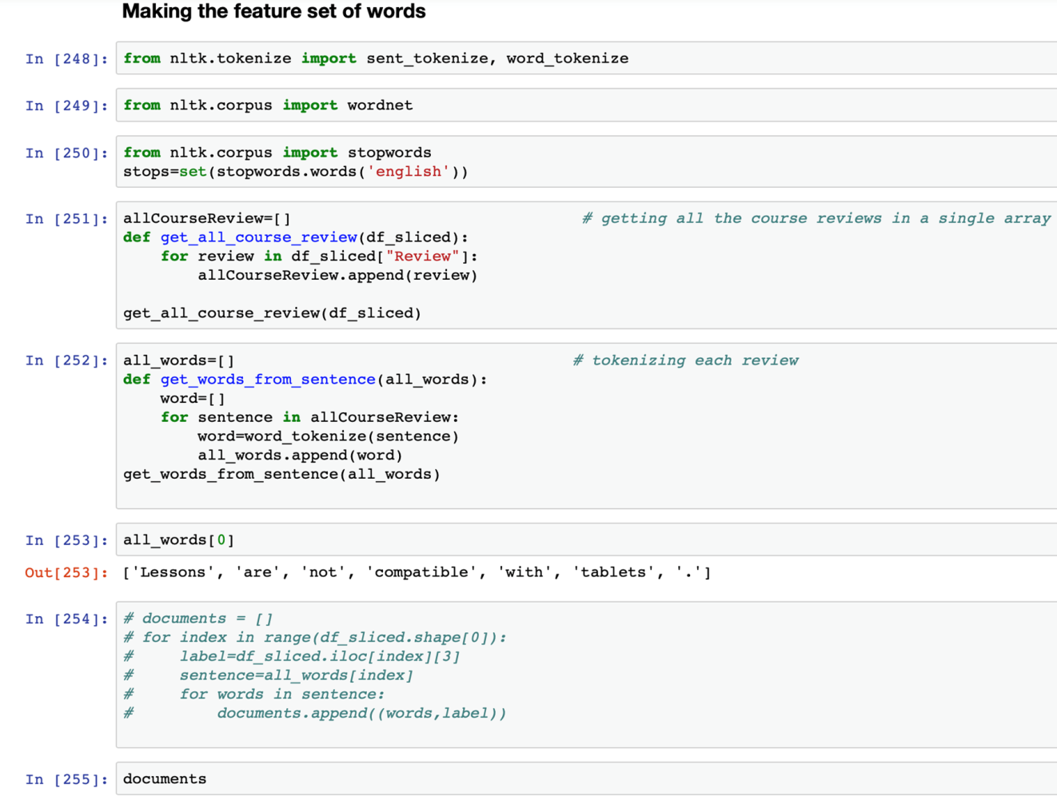

**Figure 12: Process of making the features using the function the get_from_sentence()**



**Figure 13: Get all the reviews of considered courses**

The above explained function gets the names of the courses for which reviews have already been considered after pre-processing (please refer Figure 13).



**Figure 14: Tokenize each sentence**

Tokenizing each sentence and to get words from each sentence, the above function *get_words_from_sentence* have been used which gets a review as an argument and divides it into words and then stores them into words python list (please refer Figure 14).

**Figure 15: Relating words to labels**

Once the words have been tokenized they have to be related to a label for the purpose of training to make a classifier which understands to relate each word to a good or bad review context (please refer Figure 15).

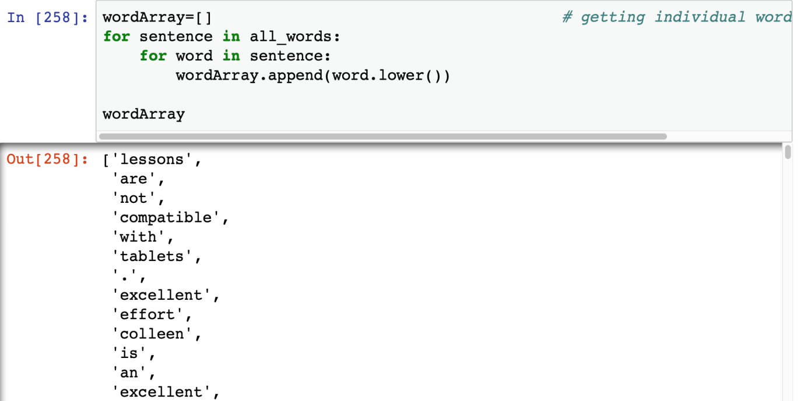

**Figure 16: Getting individual words**



**Figure 17: Removing stop words**

In order to optimize the process of training, all the unnecessary words are removed by using the *nltk.stopwords* which includes a list of all unnecessary words that can be removed from the text (please refer Figure 16 and 17).



**Figure 18: Getting the frequency of clean words**

This gives the list of most common words which occur in the selected review and also gives an insight as to which words to remove further (please refer Figure 18). Selecting 3000 words as the feature set where if any word one of these if present or not present can help identify the sentiment (please refer Figure 19).



**Figure 19: Selecting 3000 words**



**Figure 20: Function to create a 2D list**

This function makes a 2D list or a key value dictionary where, if a word is present in the current review it gets true for the corresponding word from the feature set of words, else false (please refer Figure 20). The **complexity** of proposed algorithm is **O(n*m)** where ‘*n’* is the size of review and ‘*m’* is the number of feature set words (which in the considered case is 3000).

1. **Training process**

Once the feature section is done, the training process is initiated where Naïve Bayes have been used from the *‘nltk library’* so that the reviews get classified within the category of 1 or 5. The cross validation is used to divide the reviews into two sets where, 80 % data is assigned for the training and 20 % for testing. This has been particularly done so as to avoid overfitting of data. The process of training involved 10 min approx .

The input for prediction is a feature set where the tuple is true for each word of the features present in the current review and false otherwise. The classifier gives an accuracy score of 71% and the most informative features have been shown in Figure 21.

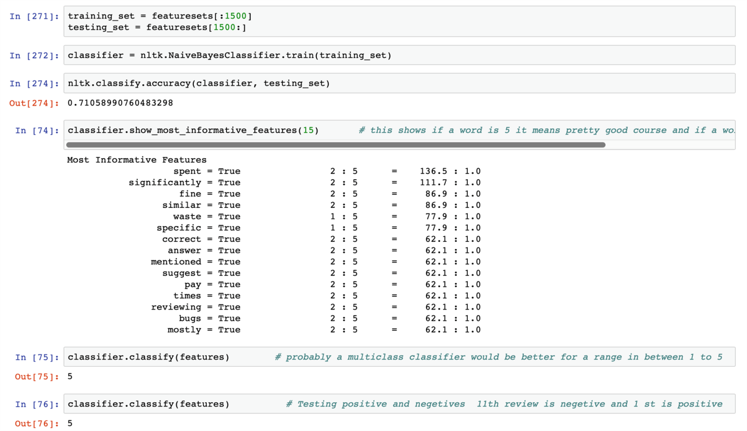

**Figure 21: Most Informative Features during the Training of the Classifier**



**Figure 22: nltk inbuilt classifier**

In the proposed algorithm, the classifier used is the *nltk’s* inbuilt classifier Naive Bayes . This is a probabilistic classifier which works on the above made feature set (please refer Figure 22).



**Figure 23: List of Most Informative Words**

Figure 23, shows words that are most informative words which help differentiate a review from a good or bad based on the trained classifier.



**Figure 24: Classifier function**

The above code in Figure 24 can be used to save the trained classifier for future purposes and to save time for further use. This includes saving the pickle file in write mode and then to open it in the read mode to get the saved classifier and use it.

1. **User item matrix**

After the reviews have been classified the next step is to get the user item matrix so as to create a novel model of collaborative recommendation. The user item matrix is a 2D matrix where the users are the reviewers and item, in the proposed algorithm, are the courses which the users have taken. This matrix helps classify a similar user to them and the process of recommendation gets much simpler. This can be seen in the Figure 25, 26 and 27.



**Figure 25: Storing of Numerical Data**

In order to get the train the classifier to accept numerical data, the string data values are converted into numerical values.

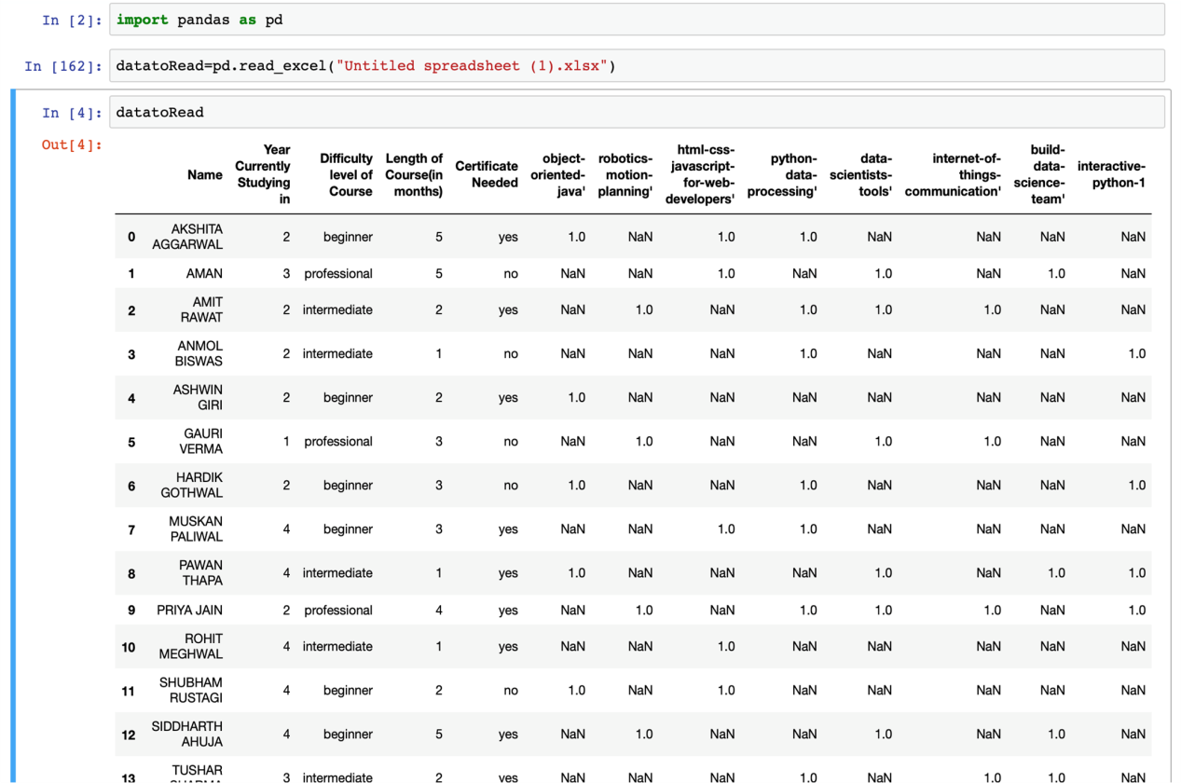

**Figure 26: User Item Matrix for Collaborative Filtering**



**Figure 27: Calculation of Scores**

The score for each user is calculated so as to get a basis for clustering for those users who have given the reviews.

1. **Scoring Mechanism**

Once the user item matrix had been made the next step proposed was to make a set of scoring mechanism for the users but the purpose involved in this case was solved temporarily using the method of averages. The proposed system intended to use k-means clustering for users to make a group and the use K-NN for classifying new users [3]. The knowledge base for the new users (cold start) is developed by asking a set of question from the new users as shown in Figure 28.

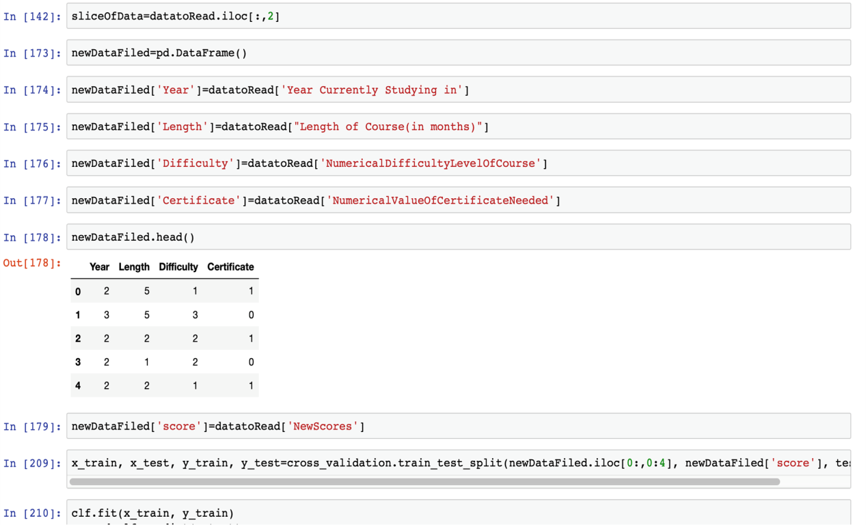

**Figure 28: Questionnaire for the New User**

The result of the recommendation model is the list of suggested courses for the aforementioned schema of the things as shown in Figure 29.

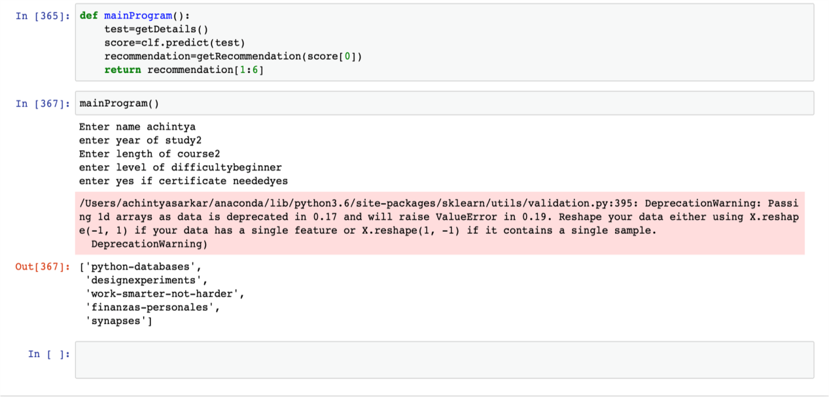

**Figure 29: Result of Recommendation**



**Figure 30: Data Slicing**

**Figure 31: Function to get details about the user****Figure 32: Building Recommendation Function**



**Figure 33: Courses recommended to the User**

Explain about Figure 30, 31, 32, 33

1. **Threats to Validity**
2. **Mortality**

The extent to which the proposed approach can expand define its limits. It might expand its reach by even suggesting YouTube channels that people should subscribe to or books to read or newsletters or blogs to look forward to and subscribe to. It can even suggest independent teachers who are teaching on web that are not yet included to the database and can even add local education centers.

1. **Maturation**

The scope of the proposed approach is to extend its reach to people through website and an application to support. This will help the people to have an easy access to most important and relevant programs.

1. **System Failure**

The system can't provide accurate results for the courses for which user have given no input about, making the system ineffective and bias against systems it is trained on. Users need to input their recommendations that might not be correct as they may not have knowledge of better courses present. Some course owners can try to make their course better by creating multiple users who recommend their course .These system failure scenarios may cause the system to give inaccurate results and hence must be dealt with.

1. **Conclusion and Future Work**

The main use of the intended project has been achieved to a certain initial degree and this will be helpful in a very strategic manner for students to get the best courses suitable for them and also it will save the time of the users. It is working with the review classifier having accuracy with Naïve Bayes of 71% and the user classifier has accuracy with the basic linear model of 60%. This here shows that many recommendation are being considered by the end users while the probability of a new course being added to their recommendation is also high the system will get better as the database of the users and reviews gains a certain depth in it. This intended project has been developed as a collective effort of the team involved in the research and its first users have also been able to give the recommendation to make the classifier better such that the end product works within certain accuracy aforementioned in the article.

The classification is performed using regression and K-means algorithm. It can be further optimized by using string matching algorithms and giving priority based scores to each feature of the user. Further the accuracy of recommendations can be improved by including content based filtering, which in turns leads to a hybrid recommendation system. The data need to be extracted from various MOOC websites and will compare courses from various courses available on other websites too.

**References**

[1] A.Tuzhilin and G.Adomavicius, “Toward the Next Generation of Recommender Systems: A Survey of the State-of-the-Art and Possible Extensions,” in IEEE Transactions on Knowledge & Data Engineering, vol 17, pp.737-749,2005.

[2] Arxiv Cornell University database of Archived Research : [https://arxiv.org](https://arxiv.org/) [Last Accessed on 28 September 2018]

[3] Github Public Database For Open Projects : <https://github.com/achin1tya/NLP> [Last Accessed on 25 September 2018]

[4] Sentiment Analysis Tools Research Based Open Articles Platform :

<https://medium.com/@datamonsters/sentiment-analysis-tools-overview-part-1-positive-and-negative-words-databases-ae35431a470c> [Last Accessed on 25 September 2018]

[5] enchant : <https://pypi.org/project/pyenchant/> [Last Accessed on 25 September 2018]

[6] nltk stopwords :<https://pythonprogramming.net/wordnet-nltk-tutorial/> [Last Accessed on 2 October 2018]

[7] Naive bayes classifier :<https://pythonprogramming.net/naive-bayes-classifier-nltk-tutorial/> [Last Accessed on 2 October 2018]

[8] C.Gupta & A.Jain “Fuzzy logic in Recommender Systems” “Fuzzy Logic Augmentation of Neural and Optimization Algorithms: Theoretical Aspects and Real Applications, pp.255-273.